Contents

LM2596 5.0V Fixed Output Result 2

LM2596 Previous Designs 5

LM2596 Design 1 using 744770133 inductor 5

LM2596 Design with 7443783533330 inductor 7

LM2596 Design with 744131 inductor 9

# LM2596 5.0V Fixed Output Result

Schematic:

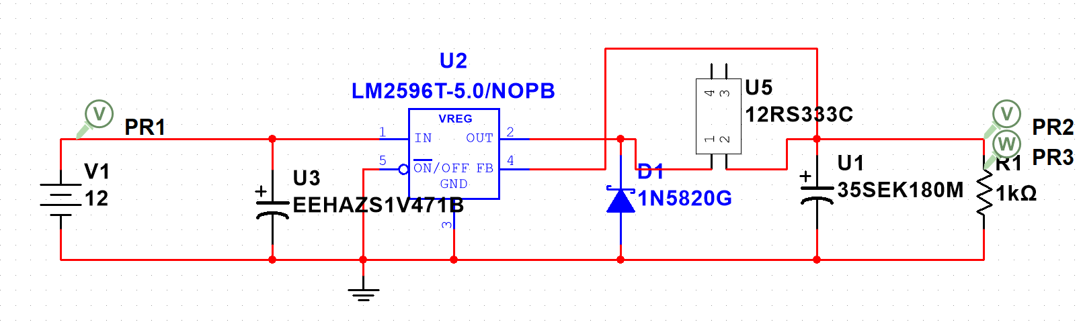

With 1 ohm load,

With 10 ohm load,

With 100 ohm load,

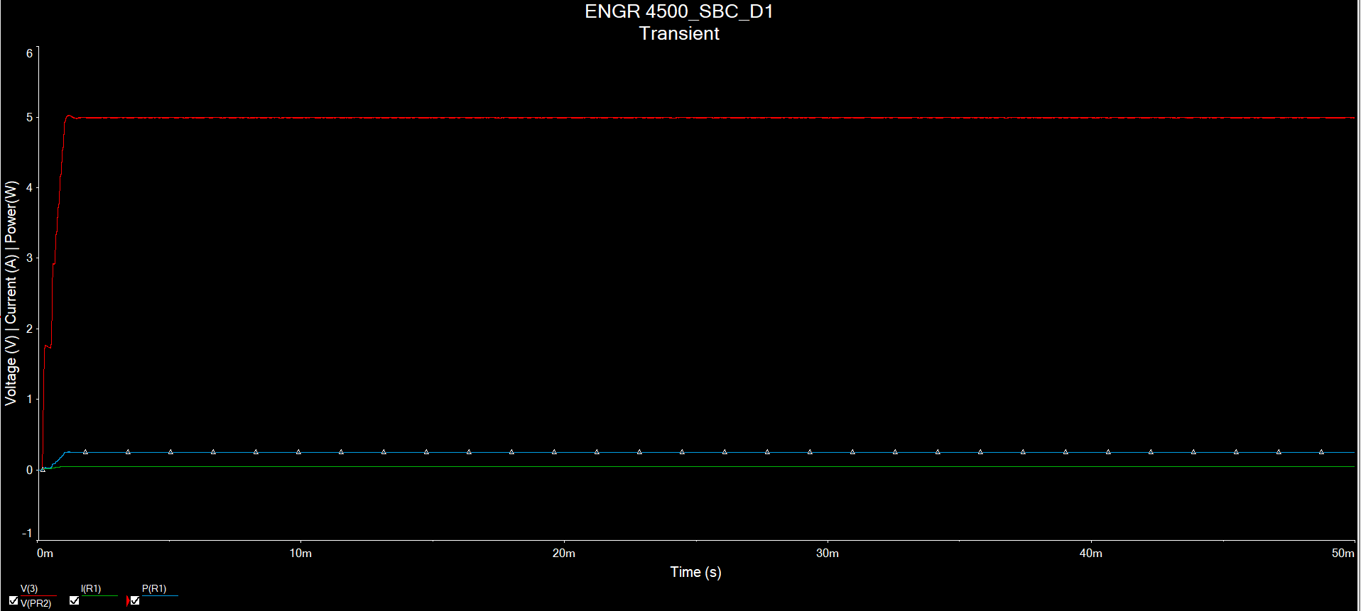

With 1k ohm load,

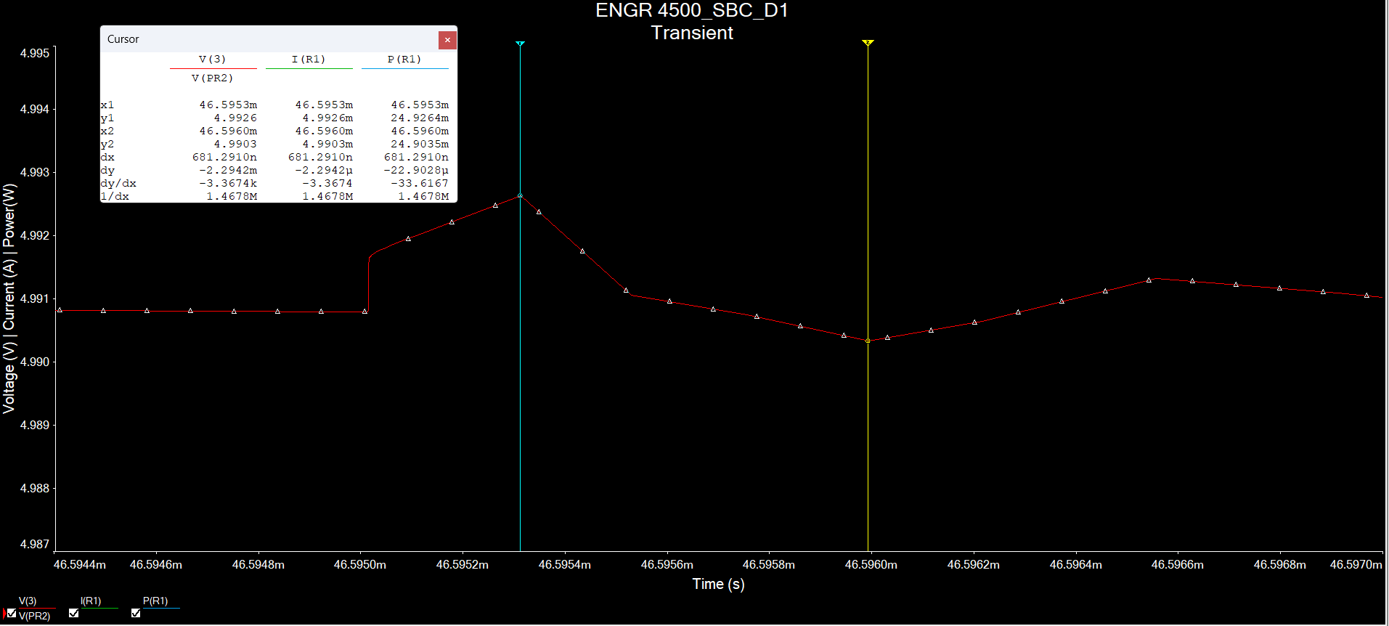

Max Voltage: 4.9912V and Min Voltage: 4.9882V. Difference:3*10^-3V

$$ΔV=\frac{\left(3*{10}^{-3}\right)}{5}⋅100=0.06\%$$

Notes

* Current draw depends on resistor load (i.e 50mA for 100 ohm)
* Voltage hangs around 4.99V to 4.998V (never fully reaches 5V)
* There is voltage ripple around the output (noticeable for lower resistive loads)

# LM2596 Previous Designs

## LM2596 Design 1 using 744770133 inductor

Schematic Design

Simulated Results

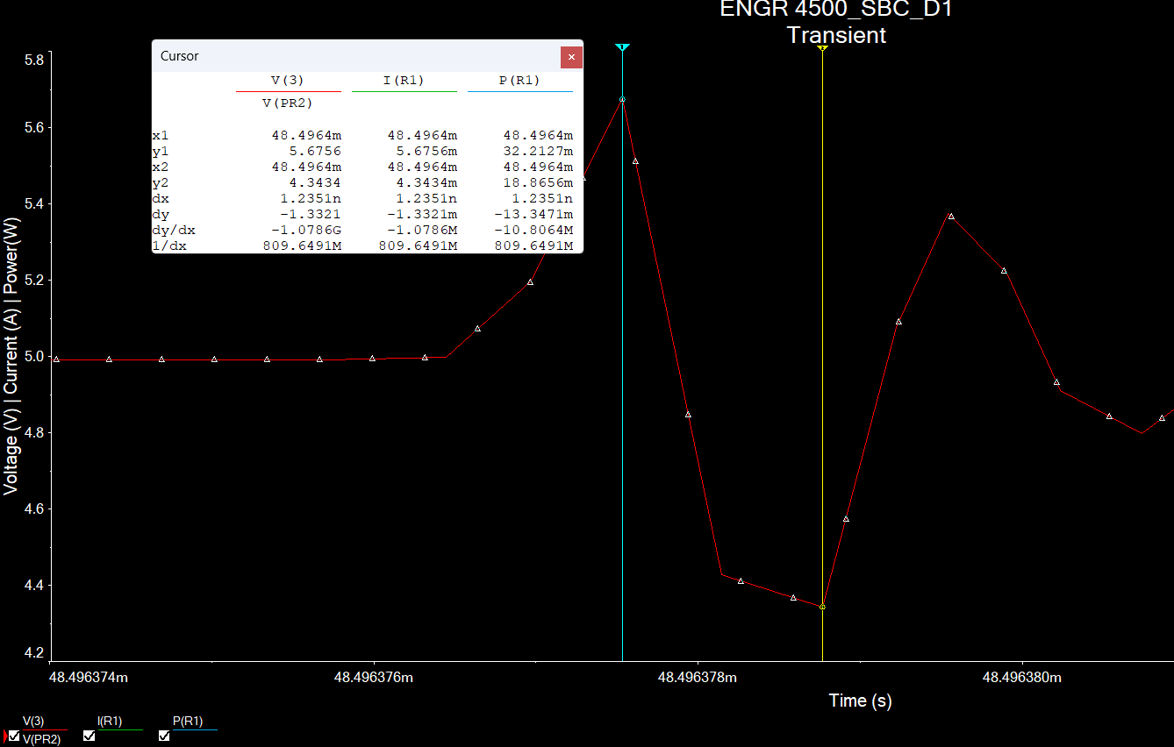

Max Voltage: 5.6756V and Min Voltage: 4.3433V

Difference between them is 1.3323V

## LM2596 Design with 7443783533330 inductor

Schematic:

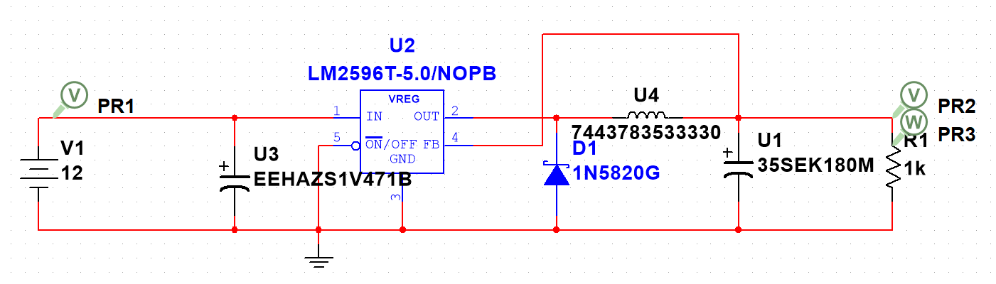

Simulation:

Max voltage: 6.5462V and Min Voltage: 2.8625V. Difference: $6.5462V-2.8625V=3.6837V$

$$ΔV=\frac{3.6837V}{5}⋅100=73.674\%$$

## LM2596 Design with 744131 inductor

Schematic:

Simulated Result:

Max Voltage: 5.6604V and Min Voltage: 4.1048V

Difference: 1.5556V

$$ΔV=\frac{1.5556V}{5V}⋅100=31.112\%$$

## LM2596 Design Ideal

Schematic

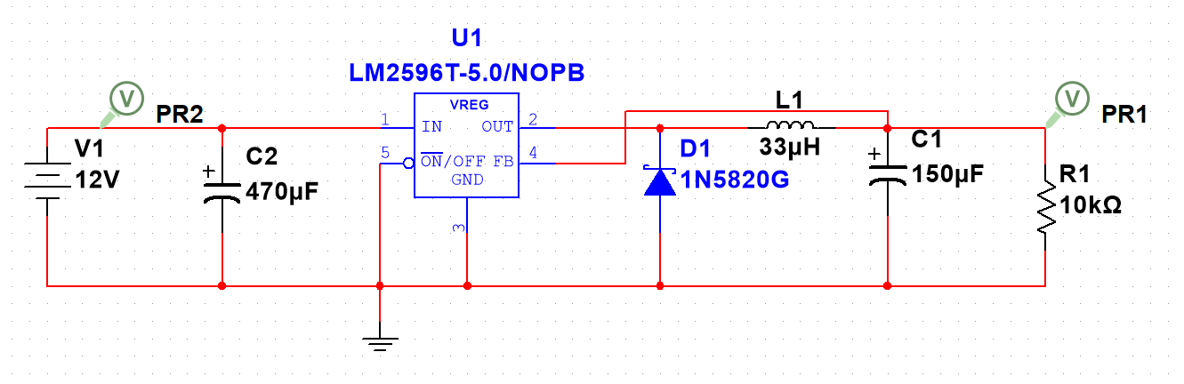

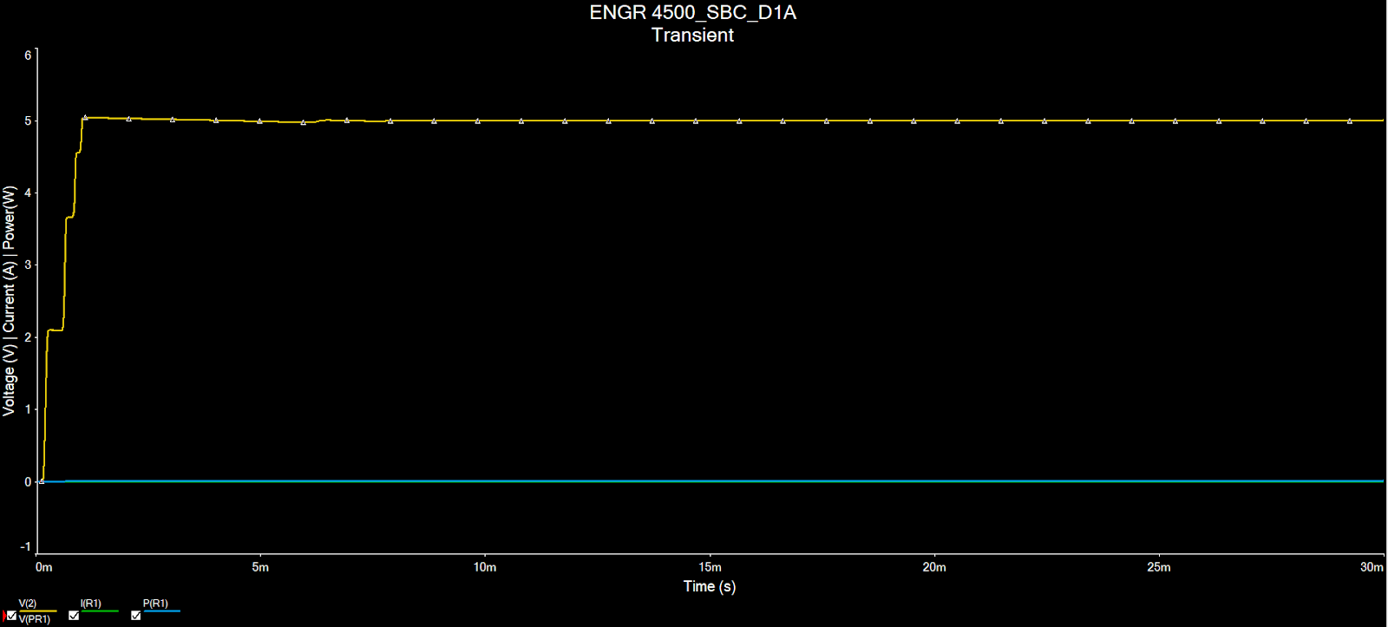

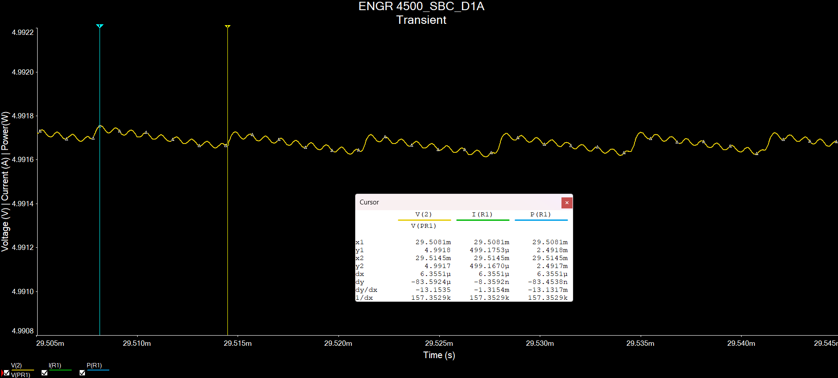

$$ΔV=\left(\frac{4.9918V-4.9917V}{5V}\right)⋅100=0.002\%$$